**SPRINT ONE – WEEK TWO September 25, 2018 Heather Peterson**

**Predefined employee_ID’s (MongoDB collection)**

{

employee_ID: 81710,

employeeName: “Jane “ + “Smith”,

}

*(have at least one, no more than 5.)*

**MongoDB database design -**

*Business Rules*

A user can log-in to access one or many quizzes.

Many quizzes can be accessed by one or many users.

A user can access their stored results,

Stored results can be accessed by the user.

A user can take one or many quizzes.

One or many quizzes can be taken by one or many users.

A quiz can have many questions.

Many questions can be on one or many quizzes.

A question can have one or many answers.

Many answers can be on one or many quizzes.

**ORD**

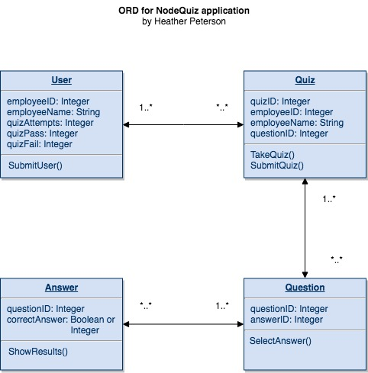

**NoSQL Document Diagram (added Results collection)**

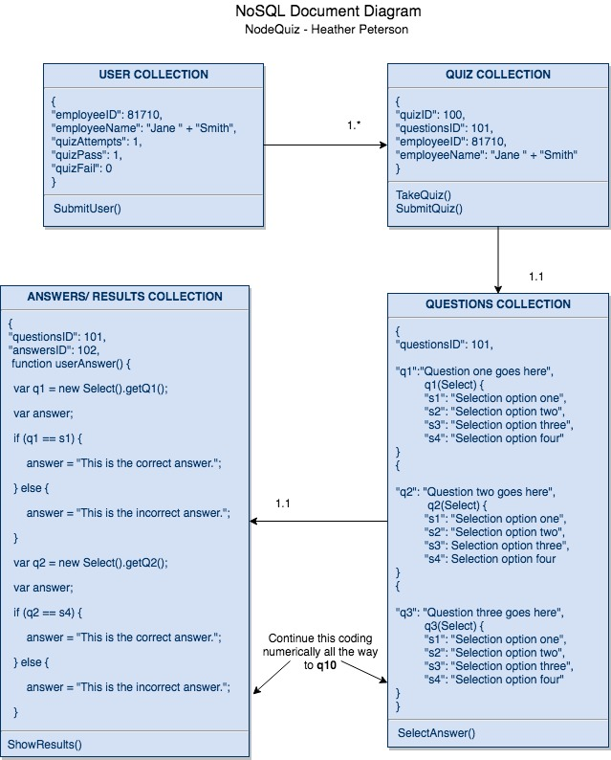

**NoSQL Data Structure**

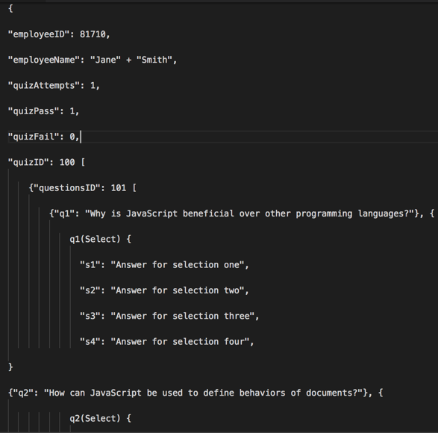

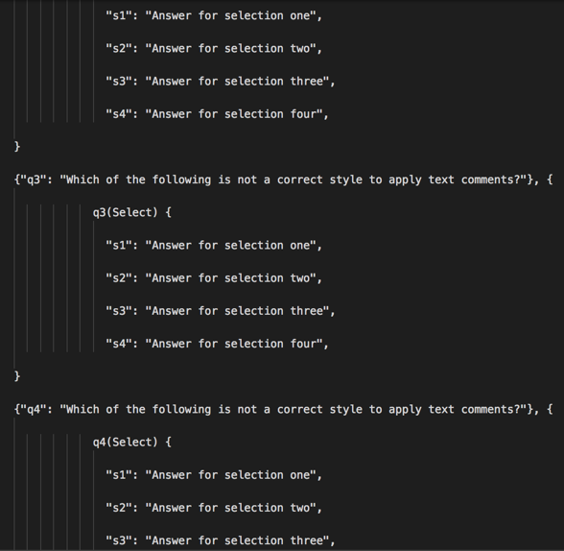

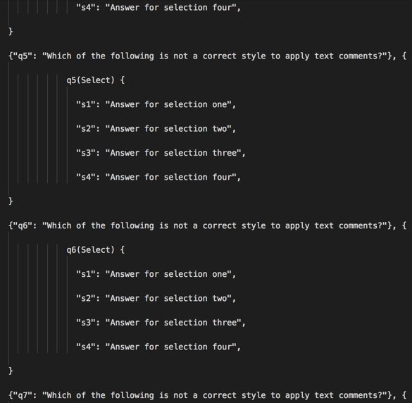

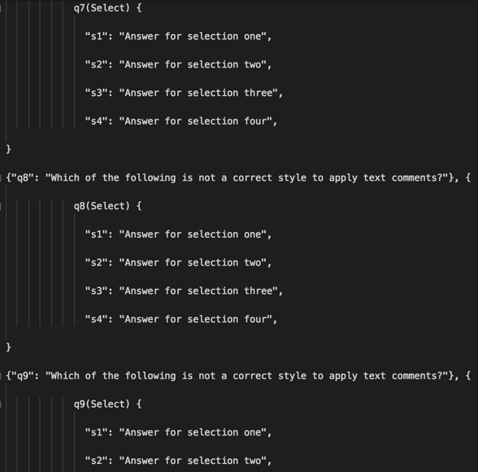

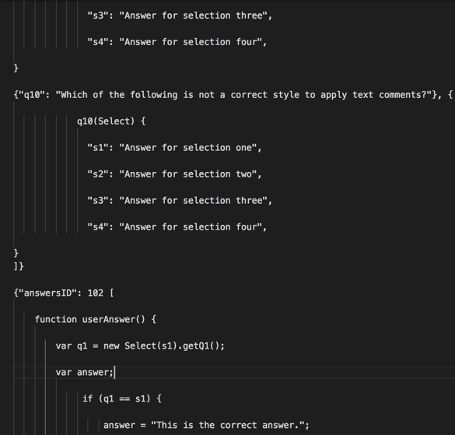

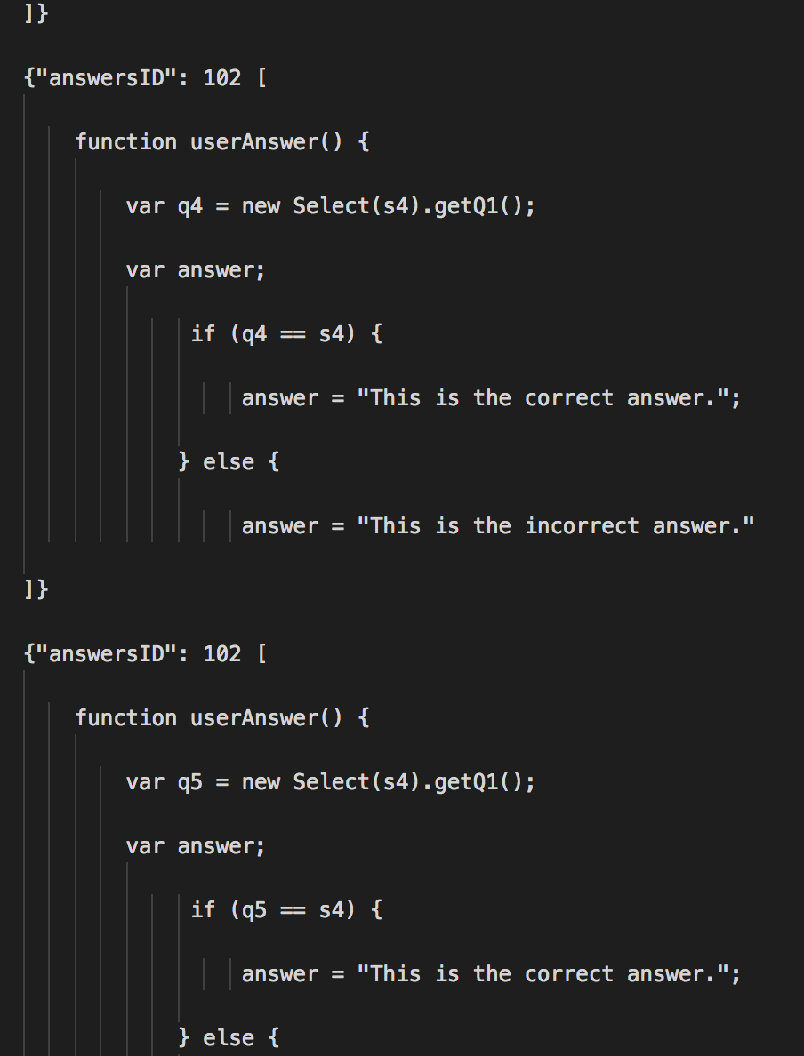

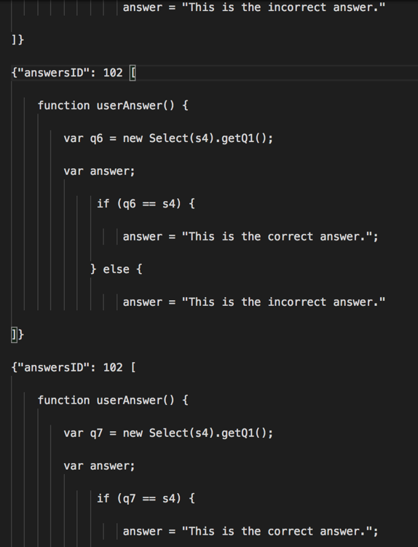

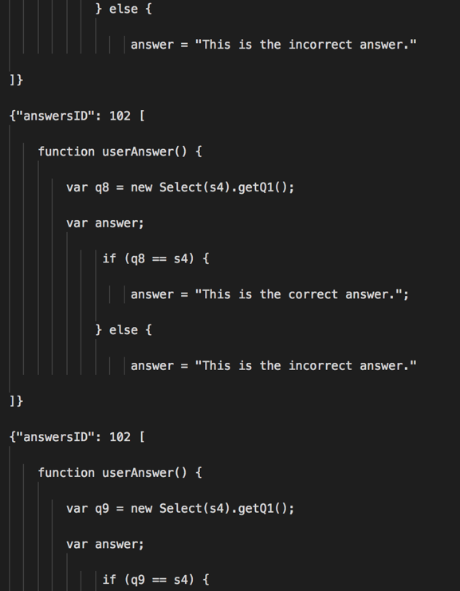

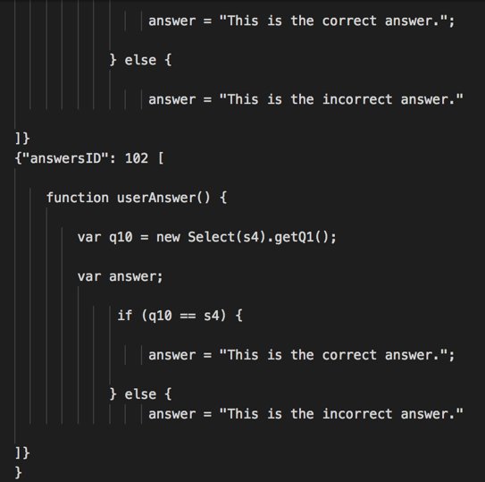

**Running Login Page (working Employee ID entry and “Welcome!” greeting)**

